# Test Strategy

## Purpose of the document

The purpose of the document is to detail out test strategy for testing the Generate User Api to make sure it works appropriately in all the supported locales.

## Assumptions

* This document is written with an assumption that the testing here is limited to one single api and it is static mean it won’t change every day
* There is no other dependent services for the api to work hypothetically
* No authentication is needed for me to test the api

## In Scope

* API functional testing
  + Positive testing
  + Negative testing
* API load testing
* API Stress Testing
* Localization testing
* Log & Metrics Testing

## Out of scope

* As per the assumption the api is static and doesn’t change. so there won’t be any regression coverage. Functional testing is going to be every thing
* There is no service integration testing
* There is no mobile or web browser testing
* Security testing is out of scope as we can call the api

## Test Environment

We will Test the api by bringing up the docker environment on our laptop and making the api up and running on localhost:3000/generate

## Test Strategy

### Manual Functional Testing approach

We will use Post man tool to send post requests and validate the response of each call in different locales. Also we will modify the headers and see the output is expected

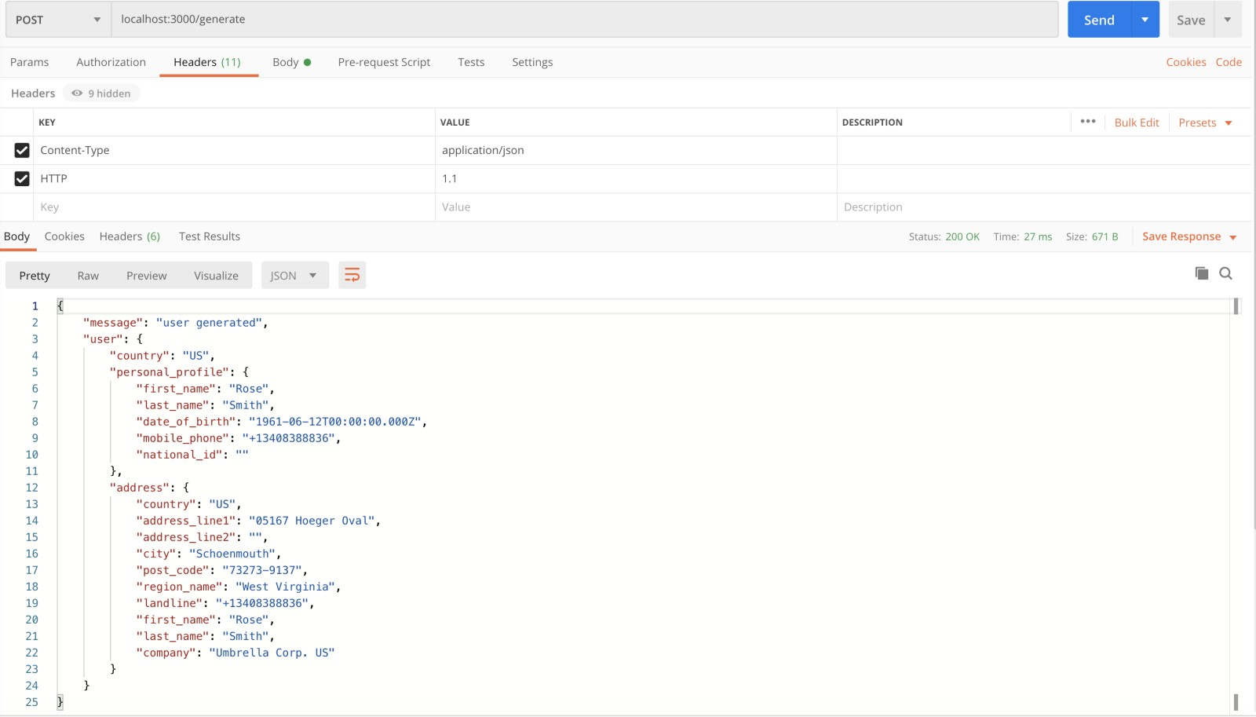

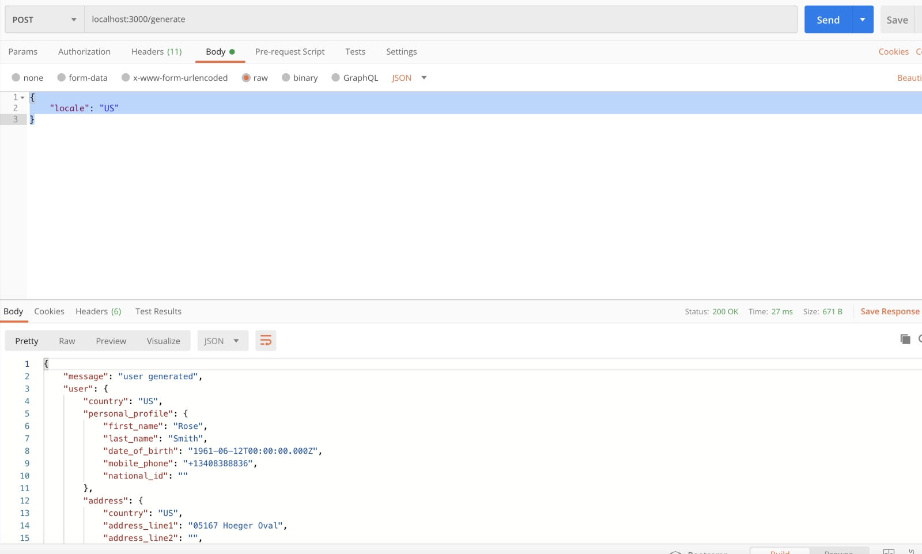

### Automation

* Functional testing and performance testing can be automated. For this assignment I am limiting myself to automate functional testing. Performance testing can be automated with JMeter

## Detailed Test Cases

### Functional Tests

#### Positive tests

* Generate users of all different locales and validate the response of user details is as per specification of the locale
* Generate user of all locales and validate response of the address details is as per specification
* Generate users of all locales and validate response of Country is accurate
* Validate some critical field like DOB and phone numbery using marshaling/unmarshaling using POJO class

#### Negative tests

* Invalid locale
* Invalid header
* Empty locale
* Invalid URL
* Null locale

*Issues:*

Some of the locale like AL doesn’t have valid address, postal code and phone number

I have automated some set of negative and positive tests using rest assured, java and testing. Please refer to the code. The intent I considered there is to show how I would structure my test framework and tests and the utilities. So I tried to pick few tests of each component but not elaborately automated every single test case. Please revert if you want me to improve and I will be glad to do the same.

### Api load Testing

* Load testing refer to how system reacts to expected peak load. The final expectation is it should work well.
* Test with 500 transactions per second and I expect 90% of the requests have response in less than 1ms is one of the expectation for example
* I can use open source tools like JMeter to do this tests

### Api stress testing

* Stress testing refers to gradually increasing the load to see where the system fails
* Example test scenario would be increase the load from 5 transaction per second and increase 5 transactions every minute , keep on increasing until 0 requests fail and 10% of requests fail
* So we know what is the maximum capacity we can support and maximum capacity with 10% error rate
* I can again use JMeter to run the tests

### Localization Testing

* I would test the response of each and every supported locale in the list of locales provided

In General in the test plans I will include the QA timelines, Risks. Miiigation plans, Supported devices etc. But I am skipping them as they are not applicable here.